**SUMÁRIO**

1. Instale o SQL Server Performance Dashboard Report 3

2. Configurar o SQL Server Dashboard Report 6

3. Utilizando o SQL Server Dashboard Reports 7

## Instale o SQL Server Performance Dashboard Report

Next.

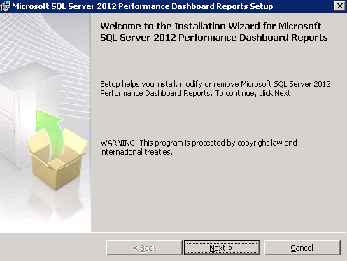

Next.

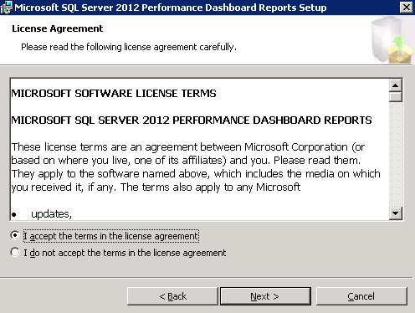

Next.

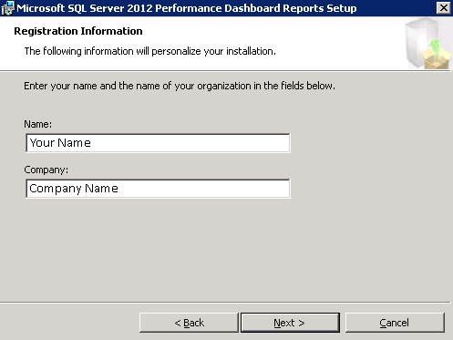

Next.

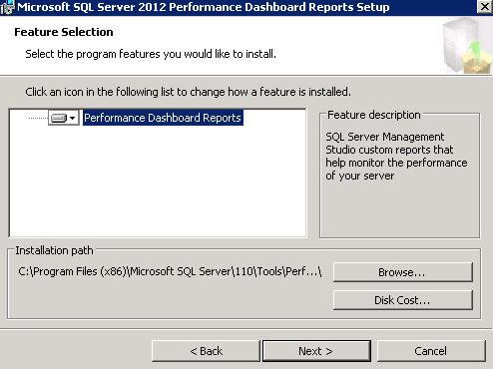

Install.

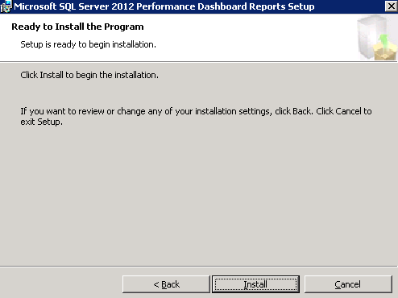

Finish.

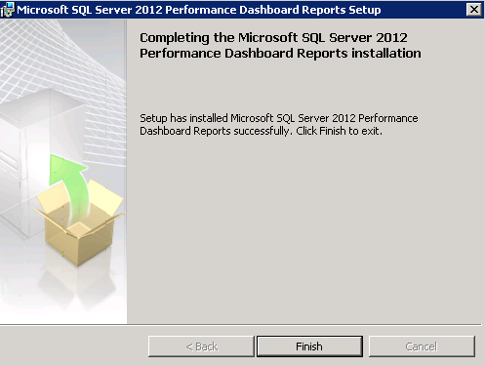

## Configurar o SQL Server Dashboard Report

Abra e execute o Script 'setup'.

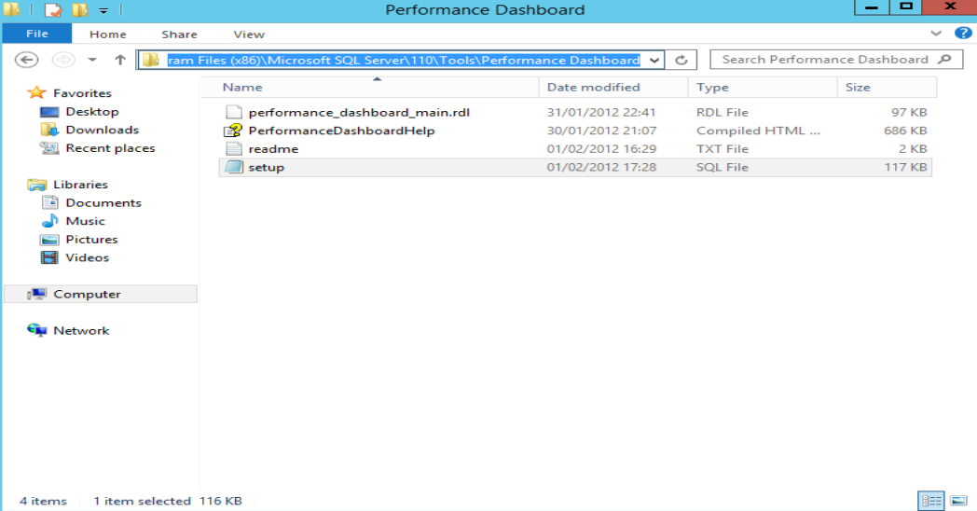

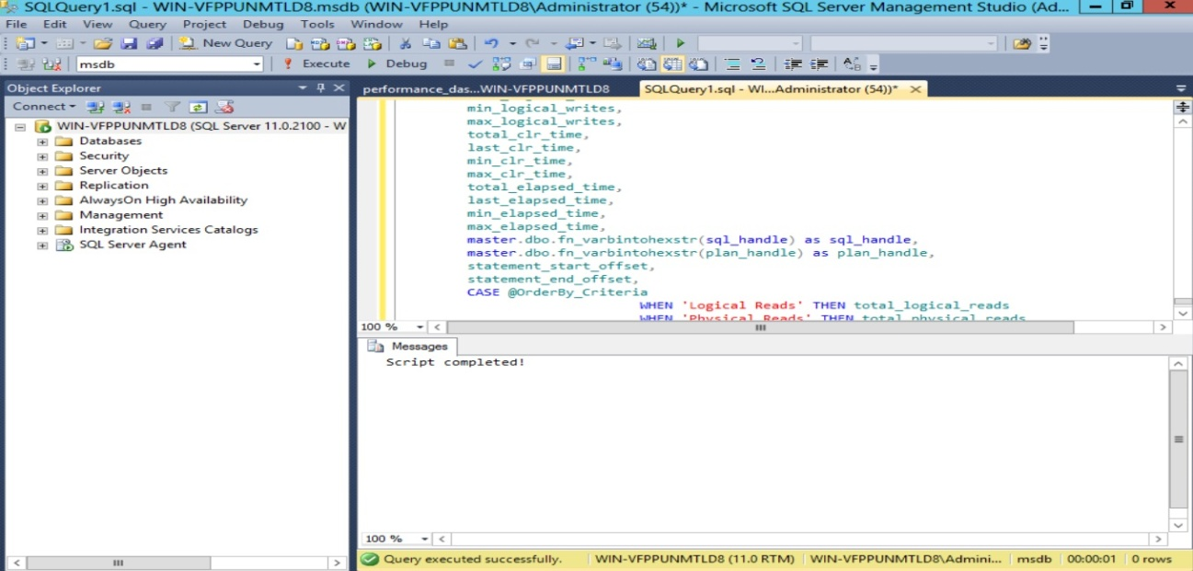

## Utilizando o SQL Server Dashboard Reports

Selecione 'Reports', e então, 'Custom Reports...'

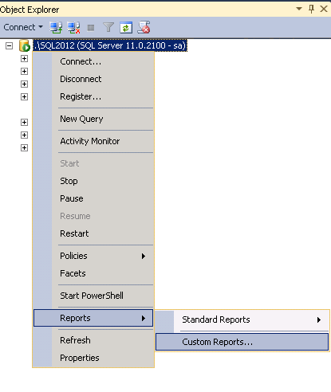

Selecione e execute o 'performance_dashboard_main.

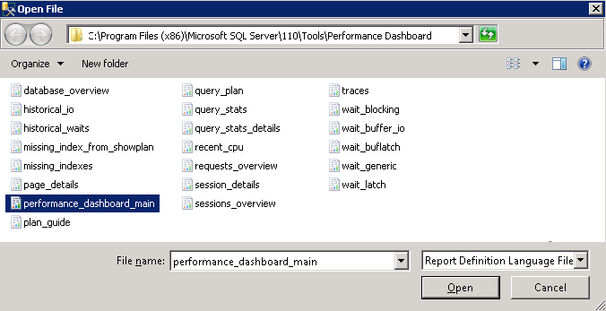

Run.

